|  |  |  |  |  |  |  |  |  |
| --- | --- | --- | --- | --- | --- | --- | --- | --- |
|  | | | | | | | | |
|  | | Capstone Project-Final Report on Chatbot | | | | |  | |
|  |  | | | | | | |  |
|  | | | |  |  | | | |
|  | | | | AkibBharatChandanKomal |  | | | |
|  | | | |  |  | | | |
|  | | |  | | |  | | |



|  |  |  |  |  |  |  |  |  |
| --- | --- | --- | --- | --- | --- | --- | --- | --- |
|  | |  |  | | |  |  | |
|  | | Mentor- Rohit | | | | |  | |
|  | |  |  | | |  |  | |
|  | Problem Statement Summary: One of the biggest industries in world suffering with the employee’s accident and major injuries and sometimes employee’s also die in such environment. Our task is to create NLP based Chatbot so that professional get details of safety risk as per accident description. | | | | | | |  |
|  | Dataset & Observations | | |  |  | | |  |
|  | Dataset consist details of 12 different plants and have records as  [“Date”, “country”,” Industry sector”,” Accident Level”, “Genre”, “critical Risk”, “Description”]  with 425 rows and 11 columns | | |  | 1. Dataset has 425 rows and 11 columns 2. Mining sector is impacted by all level of accident, most accidents have recorded with minimum severity level for mining sector. | | |  |

1. Men are involved in all level of accident where female are involved in 1st and 2nd level only which is minimal accident level.
2. Most of accident causes is not defined properly as it is selected as OTHER but few major accident causes are “Pressed”, “Manual Tools”, “Chemical substances”, “Cut”, “Bees”, “Venomous Animal”
3. City number 3 is involved in most of accident where city number 12 is involved in minimum accident.
4. City number 3 and 4 are involved in all type of accident level.

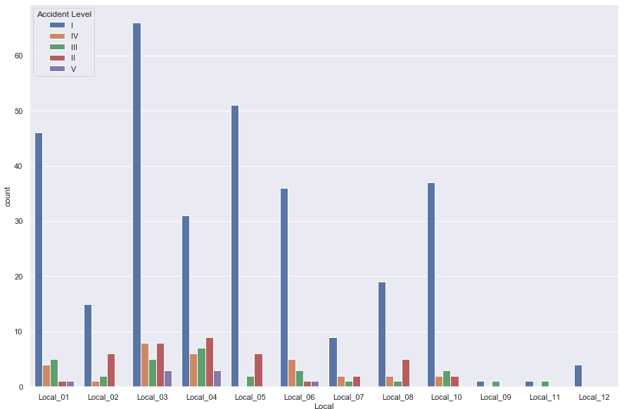

1. Most and all type of accident levels are recoded in mining sector followed by metal industry sector.
2. We can observe that most of accident have minimal accident level but high potential risk.

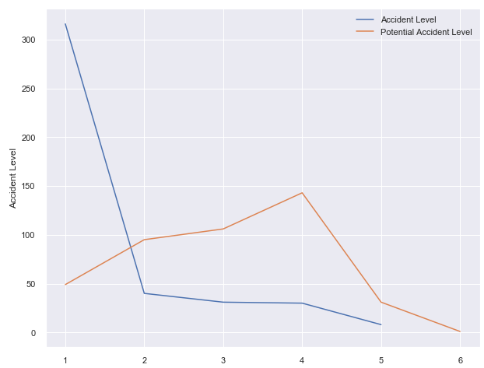

1. There are high number of accidents have been recorded in 2017-07 and 2017-07

|  |  |
| --- | --- |
|  | Data Cleaning:  * For better understanding change column name from data to date and Genre to Gender. * We do not have any null value. * Removed irrelevant data (Numbers and Punctuation) and converted to lower case and tokenize data. * Removed stop words. * We have performed stemming and lemmatization. Stemming has changed most word incorrectly so we go with lemmatization where we got better result. * Removed all unwanted tokens after applying lemma which are less than two in size. * After applying lemma and other mentioned cleaning the final data is added in the *Updated Description* column.  Data Encoding:  * Bag of Words**:**      * TF-IDF encoding:      * GLoVe encoding:  Briefings:  * As we are dealing with text data here, we have considered cleansing the text data ‘Description’ so that it can be encoded properly and fed to the machine. * We have chosen *Description* column as the most salient feature as it determines the potential accident level and the accident level. |

|  |  |
| --- | --- |
|  | Walk Through the Solution:  * The goal is to predict the potential accident level. As the very first step after getting the data preprocessed and encoded the text data with TF-IDF ,GloVe,BOW. * As a next step we tried building a random forest classifier on the text data encoded. * As random forest failed to rise up to the expectation, we have tried with the text data with stop words and also with BOW encoded. But that didn’t change the result much. We still were stuck with a poor score. * By using hyperparameter tuning also nothing changed much. * The failure of the previous stages had led us in search of alternate models and we came across FastText. * In the next few steps, we have tried building up a solution based on FastText. First, we preprocessed the text as FastText requires. * In the process of building FastText we did split the data with 80:20 and came up with a model initially with 75% of accuracy. * Next, we implemented uni directional and bi directional LSTM, GRU ,Leaky Relu with GLoVe encoding, with batch normalization and dropouts. * In order to optimize and reach the target score with LSTM we created dummy matrix of size same as target column label encoding to divide data into test and train properly. * With the help of previous steps, we got a descent score of 75%. * But our target was to create a model of 90% or more. As LSTM after tuning and optimizations didn’t give us the expected outcome, we switched back to FastText. * As the final step we did some hyper parameter tuning on the FastText by changing the n-grams and epochs, we finally reached there. * At this point we had all our model ready and evaluated. As FastText performed best on the test data we have chosen the FastText as our model to go forward. * From here, we worked on different APIs and finally able to integrate our model with an interactive desktop application.   So, to summarize, as we approached different ways to solve the problem, we finally found it through FastText after working with multiple models mentioned above. |

|  |  |  |  |  |  |  |  |  |  |  |  |  |  |  |  |  |  |  |  |
| --- | --- | --- | --- | --- | --- | --- | --- | --- | --- | --- | --- | --- | --- | --- | --- | --- | --- | --- | --- |
|  | Model Evaluation:   Below table gives us a clear picture on how we decided our final model.   |  |  |  | | --- | --- | --- | | **Model Name** | **Accuracy** | **Comment** | | Random Forest Classifier | 41.40% | We got very bad accuracy with RFC | | FastText | 99.70% | We got very good accuracy with FastText model with epoch of 300 | | Bidirectional | 73% | We got decent accuracy with bidirectional but there is huge difference between accuracy and val_accuracy | | LSTM | 42% | as compare to above model accuracy is low and same is above huge difference between accuracy and val_accuracy | | GRU | 0.9% | as compare to other models, accuracy is low and same is above huge difference between accuracy and val_accuracy |  * We decided FastText as the final model. This is a supervised classifier and is an open-source, free, lightweight that allows users to learn text representations and text classifiers. It works on standard, generic hardware. * In order to preprocess FastText requires ***__label__*** on each target value to train a model. * To improve the performance, we did some hyperparameter tuning with ***wordNgrams***and ***epoch****.* * As the dataset was small and it’s difficult to up sample the text data, we did validate the performance of our model on both the test and with the whole dataset. It performed well with very high precision and recall.  Model Details:  * **Preparation**: * Fastest expect “_label_” in column, added same in target column. * Saved data as text file * Splitting data into test and train in ratio of 20:80 * **Model:** * fasttext.train_supervised('fastext.datas-fasttext-train.txt', wordNgrams = 2, epoch=75) * Score: (340, 0.9970588235294118, 0.9970588235294118)  Model Success: Here is the classification report attached which clearly indicates that FastText is the right model to choose. |

#### 

#### Comparison to Benchmark:

The target was to reach 90% with good precision and recall with a model. With FastText we have achieved more than that and even though for __label__III precision could be bit better but as it has performed very well with others, we can wind up saying FastText has very well set the standard here and may be exceeded the benchmark we set as a team.

#### Visualization:

Few of the observations are already mentioned in this report earlier. Here we are going to visualize the dataset in hand in more details.

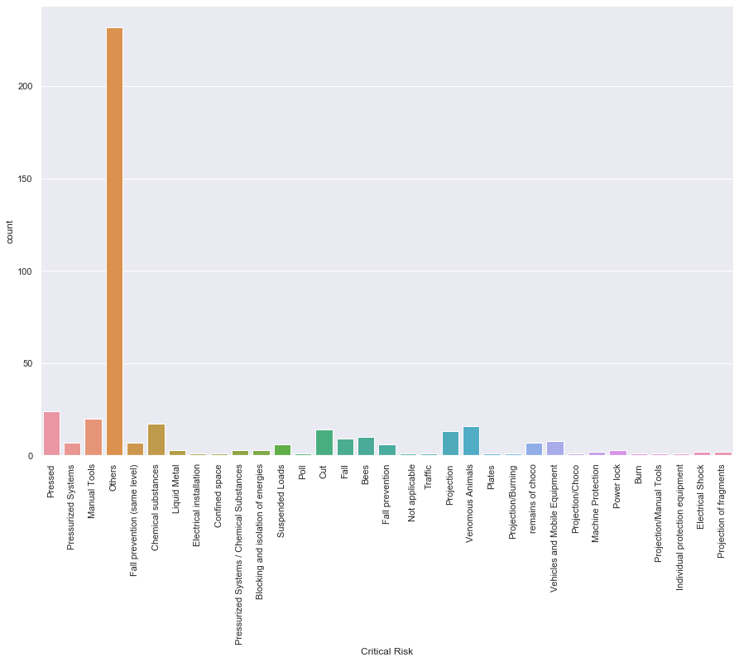

* This is the details of critical risk counts as per the data set. Most of them happened where it’s

described as *others*.

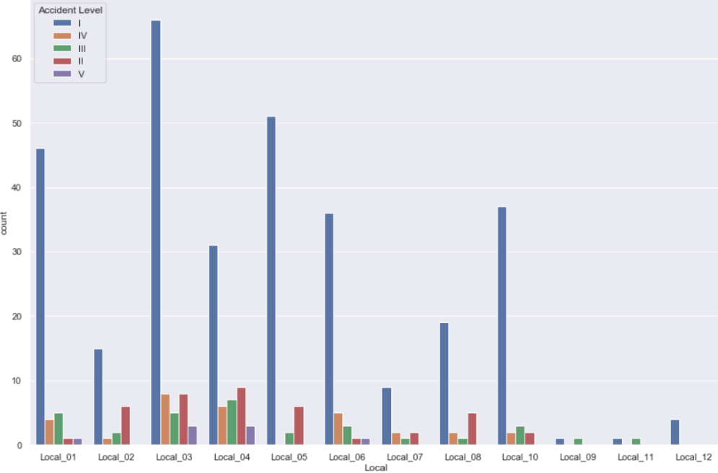

* For each local level-I accident has happened most.
* Local_03 has reported most of the accidents.

Here is another view of Critical risk over each industry:

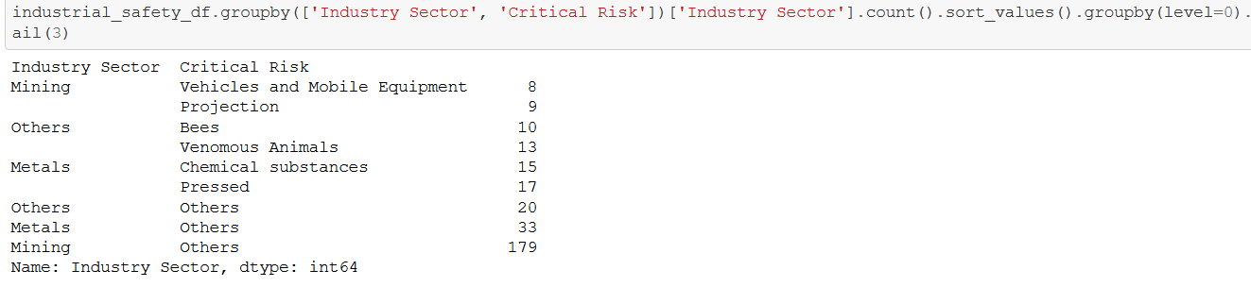

* ***Mining***industry reported most of the risks.

We will take another look on how risky Mining industry is:

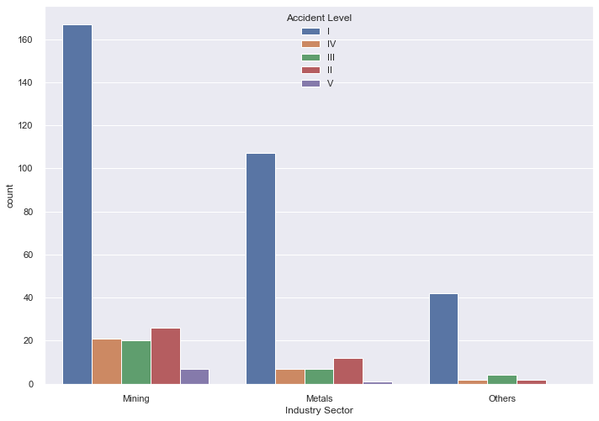

* So, *Mining* is the riskiest industry and followed by *Metals* and *Others*.
* Also, all type of accidents count is much higher in Mining as compare to the rest.
* In Metal only Accident Level I high but others are significantly less.

The dataset is rich with data containing from 2016-2018. It has three years of data as per the below time series.

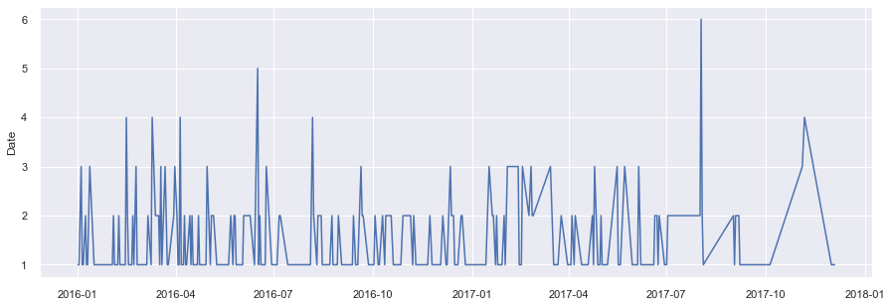

#### Implications:

* *How does our solution affect the problem in the domain or business?*
* The goal is to create an AI based chatbot which can predict the potential accident level based on the description of the accident provided by the user.
* If predicted early and correctly this bot can become a good tool to save and protect employees of the different industry sectors.
* Hence it can help the organization’s interest by reducing the risks involve with its employees.
* It can enhance the reputation of an organization in the views of its employees’ and also it can reduce the expenses associated with an accident.
* Recommendations:
* This chatbot can be highly effective in risky industries such as Mining and Metal Industries.
* As this chatbot has the ability to determine the potential accident level with very high precision we as a team would recommend this with the same level of confidence which we have achieved by testing it on real industry safety dataset.
* So, with more than 90% confidence we would be recommending it.

#### Limitations:

* This chatbot needs a detail text description of the incident to determine the potentiality of the accident which can be time consuming during any critical situation.
* It doesn’t consider the industry type, gender and age to determine the level of accident.
* It uses FastText model which is good in text classifications but unlike LSTM it can’t remember selective patterns.
* In Realtime there are such applications which can decide the next set of actions based on users input which ours’ can’t.
* **Enhancement:**

This application can be enhanced into more sophisticated software solution for industry safety by adding the some more features. E.g.

* Call SOS
* Trigger alarm based on the criticality.
* Recognize individuals voice and instead of text works on voice data.
* Deploy as a mobile Application.

#### Reflections:

* This project is the result of teamwork and collaborations. We have worked as a unit and completed all tasks in time.
* Now we have a much better understanding about AIML with deep learning as we had to learn and apply handful of those techniques in order to reach our target. Particularly we have firm grip on NLP.
* We also had a chance to work with FastText which is widely popular.
* We have an understanding of end to end application development with python using Flask.
* What could be done differently:
* We tried Random forest but never tried other supervised machine learning algorithms. It could be tried as a next step.
* This chatbot considers only text data. Instead, it could work by recognizing and analyzing voice data.
* There are other features which aren’t considered much here as of now, we could explore those features more.
* The chatbot could be more interactive and decisive.